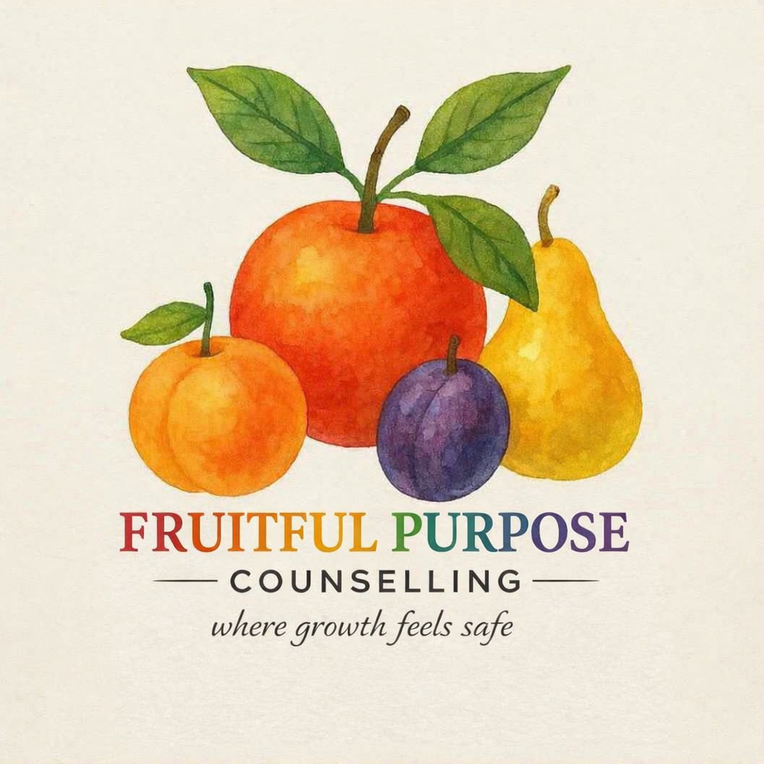

Practitioner Profile – Fruitful Purpose Counselling

Welcome
Fruitful Purpose Counselling is a faith-informed, trauma-informed practice where growth feels safe, offered in Kurri Kurri, Maitland and the Hunter Valley and online.



Qualifications and membership
Registered Level 2 member of the Australian Counselling Association (ACA), and a Certified Practising Counsellor (CPC) with PACFA and member of the Christian Counsellors Association (CCAA).
- ACA Registered Level 2
- PACFA Certified Practising Counsellor (CPC)
- Christian Counsellors Association (CCAA)
- Declutter counselling training (see below)
- Bachelor of Counselling
- Diploma of Counselling

A trauma-informed approach
Every session starts from safety: clients set the pace, choose what to share and never have to retell painful experiences to be helped.
- Safety and trust come before any deeper work
- Choice and collaboration: goals are set together, and clients can pause or change direction at any time
- Steady pacing that supports emotional regulation, so overwhelm is eased rather than stirred up
For referrers, this means your clients are met with respect and without pressure, and the support complements the care you already provide.

Declutter counselling
Trained in declutter counselling with Debbie Graham, founder of Inside Out Recovery. This adds practical, compassionate support for clients whose clutter is tied up with stress, overwhelm, grief or a life transition.

Counselling philosophy
I believe people grow best when they feel safe, heard and unhurried. Change doesn't need to be forced; it comes from understanding your story, building healthy boundaries and rediscovering what gives your life purpose. My role is to walk alongside you, with respect for your values and your faith, as that growth takes root.

Get in touch
Email hello.fpc@hotmail.com or call 0407 595 532. Sessions are available in person in the Hunter Valley and online.

